**I. Nakresli**

1) six yellow pencils

2) five red books

3) one blue and orange pencil case

4) three brown rubbers

5) two green bags

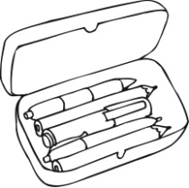 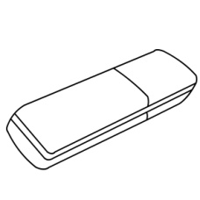 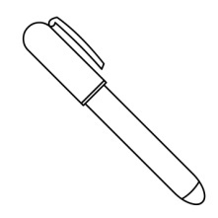 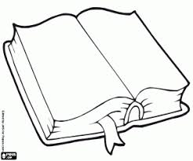 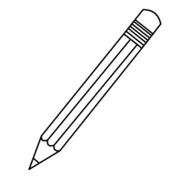

**II. Spoj**

What´s your name? I´m eight.

How old are you? My phone number is 776543021.

How are you? My birthday is in June.

What´s your phone mumber? My name is Emily.

When´s your birthday? I´m fine, thank you.

**III. Vybarvi**

three = red eleven = yellow five = blue twenty = green

four = orange ten = purple two = brown twelve = black

one = pink fifteen = red thirteen = yellow six = green

sixteen = blue seven = orange nineteen = purple nine = brown

fourteen = black seventeen = pink eighteen = red eight = yellow

**IV. Nakresli**

The ball is **under** the car. The doll is **on** the table.

The bike is **in** the garden. The boat is **under** the bed.

The plane is **in** the kitchen. The train is **on** the chair.

**V. Popiš obrázky**



   